14. Create a Virtual Hard Disk and allocate the storage using VM ware Workstation.

Aim
To create a Virtual Hard Disk (VHD) and allocate storage using VMware Workstation.

Procedure:
Step 1: Open VMware Workstation and click Create a New Virtual Machine.
Step 2: Select Typical (Recommended) and click Next.
Step 3: Enter the virtual machine details (name and location) and proceed to the Specify Disk Capacity window.
Step 4: Enter the required hard disk size (for example, 15 GB) and choose either Store virtual disk as a single file or Split virtual disk into multiple files.
Step 5: Click Finish. The virtual hard disk will be created automatically.
Step 6: The specified storage will be allocated to the virtual machine.

STEP1:
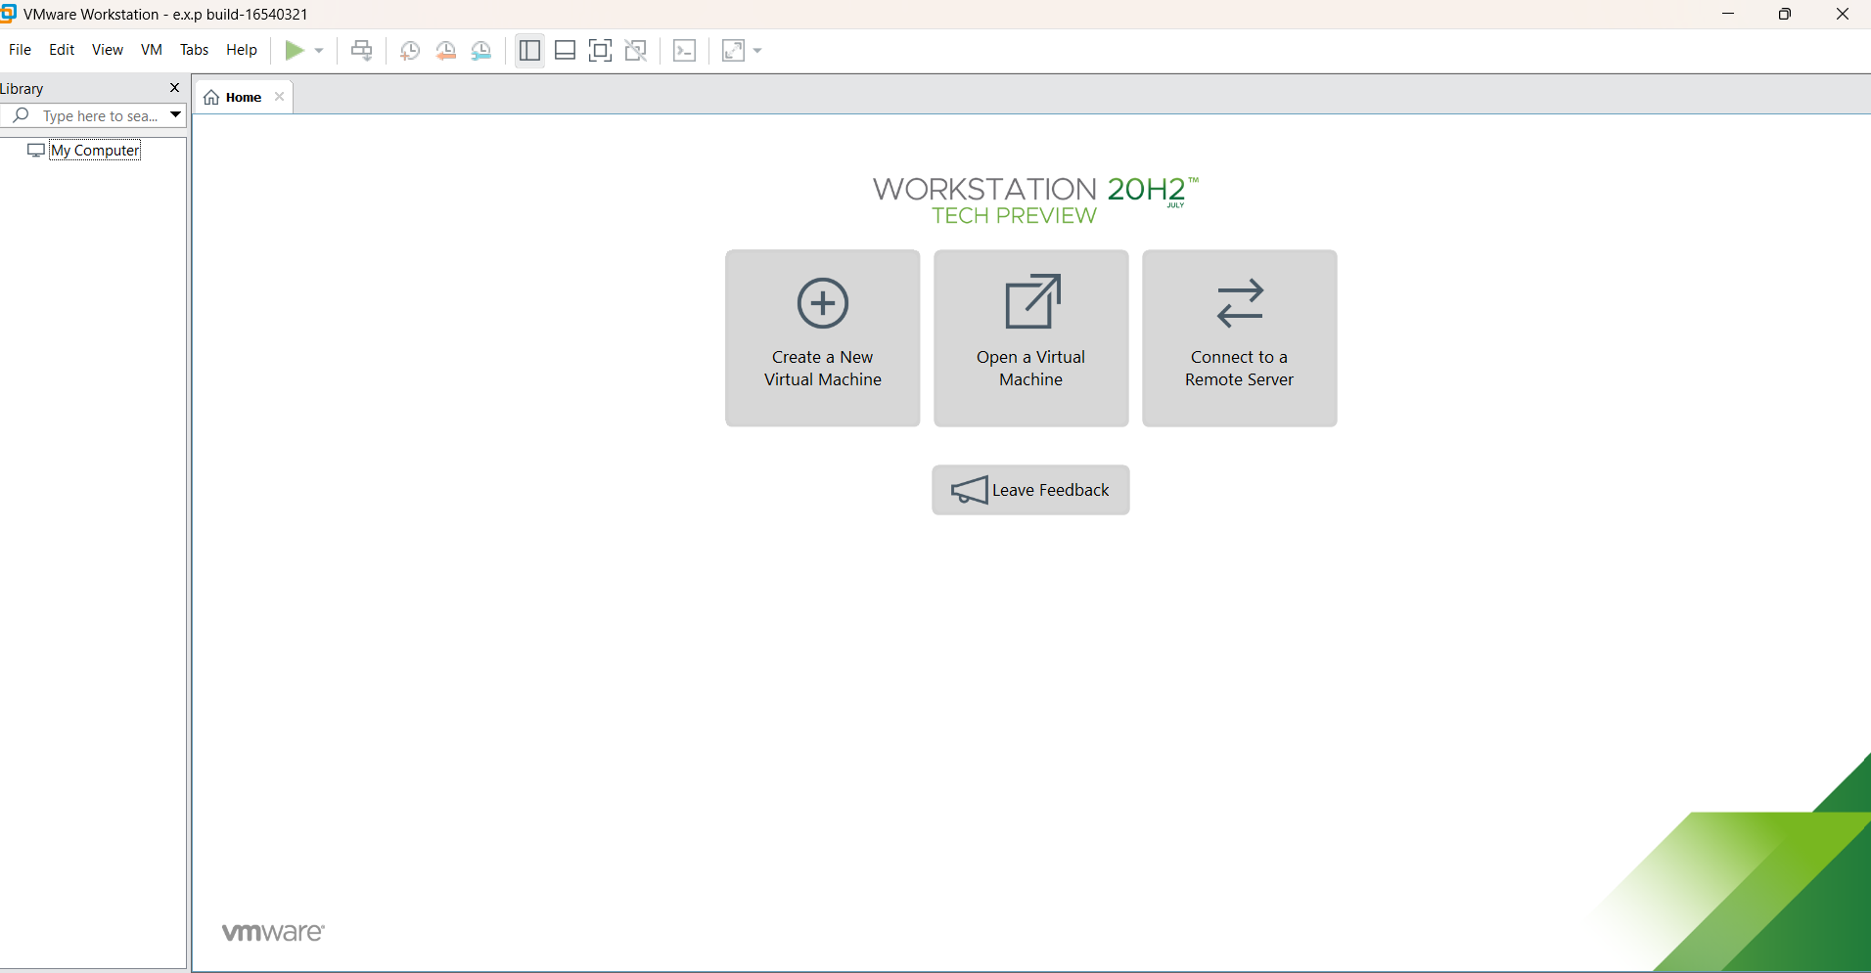
STEP2:
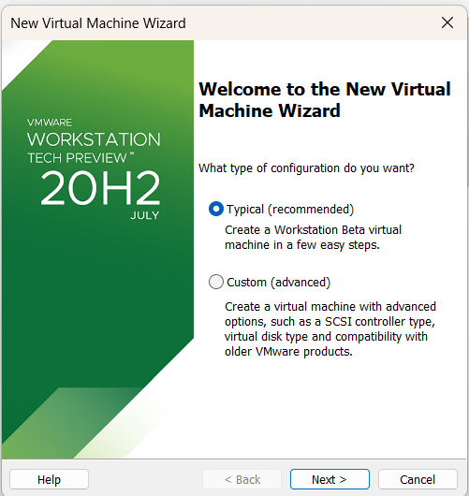
STEP3:
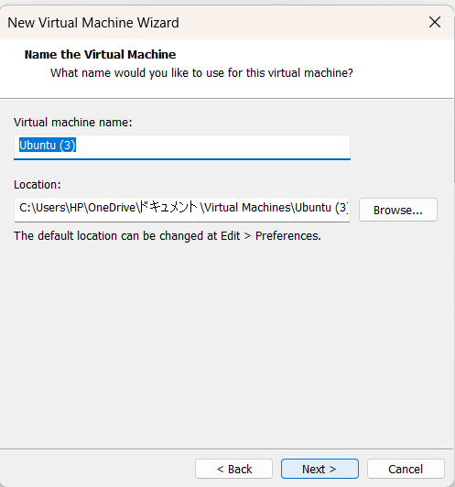

STEP4:
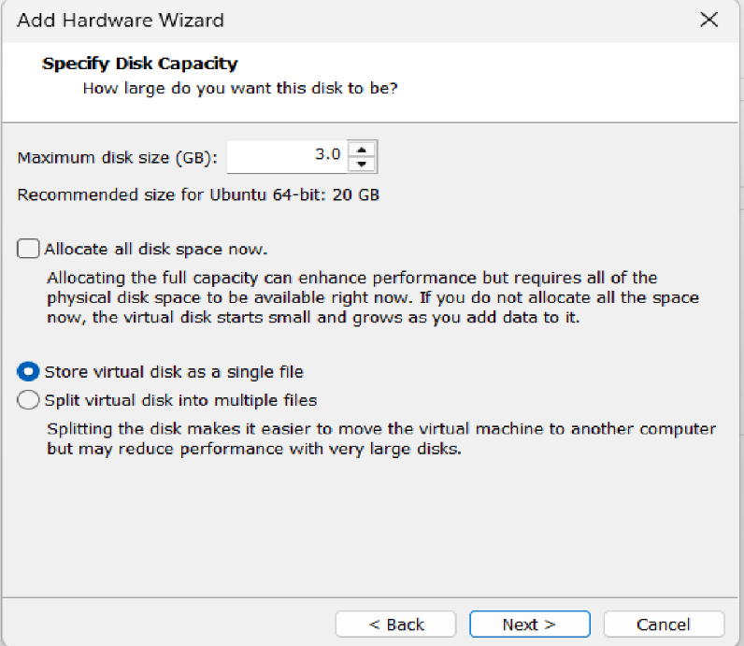

STEP5:
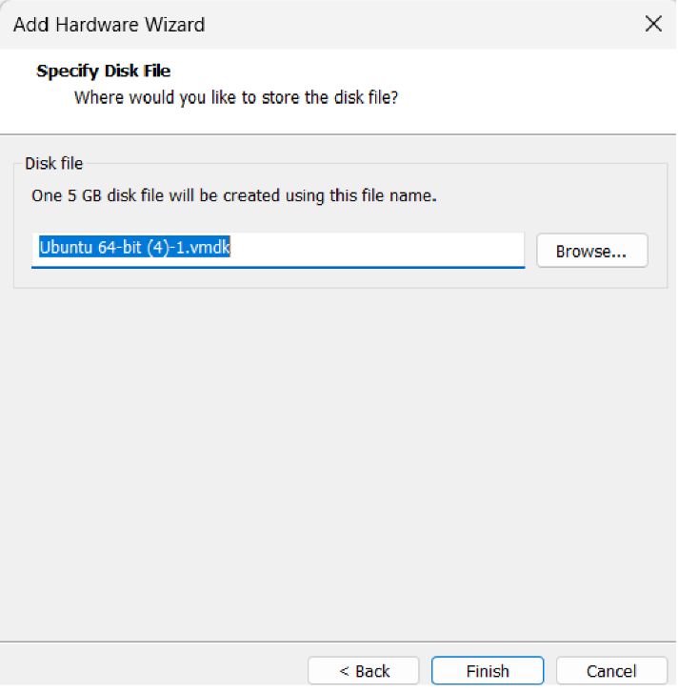

STEP6:
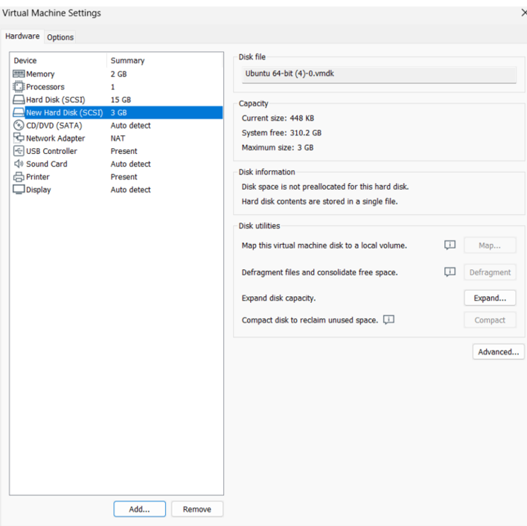

Result:
A Virtual Hard Disk of 15 GB was successfully created and storage was allocated using VMware Workstation. The allocated storage was verified in the virtual machine settings.

